PROJECT YODA   
APPLICATION STRUCTURE (DRAFT)

Application Structure

1. Data Sources
   1. Infocenter
   2. Yoda DB
   3. Canvas?
2. App Structure
   1. Data Source
      1. API Controller (Laravel)
         1. 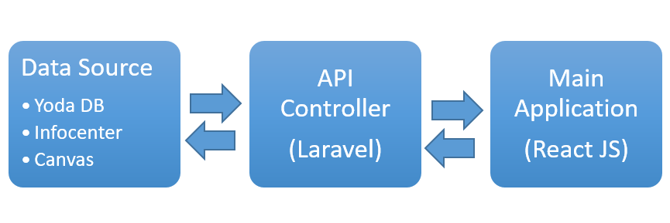View (Javascript Framework)
3. Access Structure
   1. Admin
      1. Teachers (Create/View/Update/Delete)
      2. Students (Create/View /Update/Delete)
   2. Teachers
      1. Students (View)
      2. Courses (Create/View /Update/Delete)
      3. Assignments (Create/View /Update/Delete)
      4. Grades (Create/View /Update/Delete)
      5. Posts/Messages (Create/View /Update/Delete)
      6. Calendar function (Create/View/Update/Delete)
      7. Profile (View/Update)
   3. Students
      1. Courses (Select)
      2. Assignments (Update)
      3. Quizzes (Update)
      4. Grades (View)
      5. Messages (Update)
      6. Profile (Update)
   4. Parents
      1. Grades(View)
4. Main Modules
   1. Profile
   2. Courses
      1. Grades
      2. Assignments
      3. Quizzes
   3. Assignment Engine
      1. Grades
   4. Quizzes
      1. Grades
   5. Grades
   6. Messaging
   7. Single Sign On
   8. Calendar
   9. 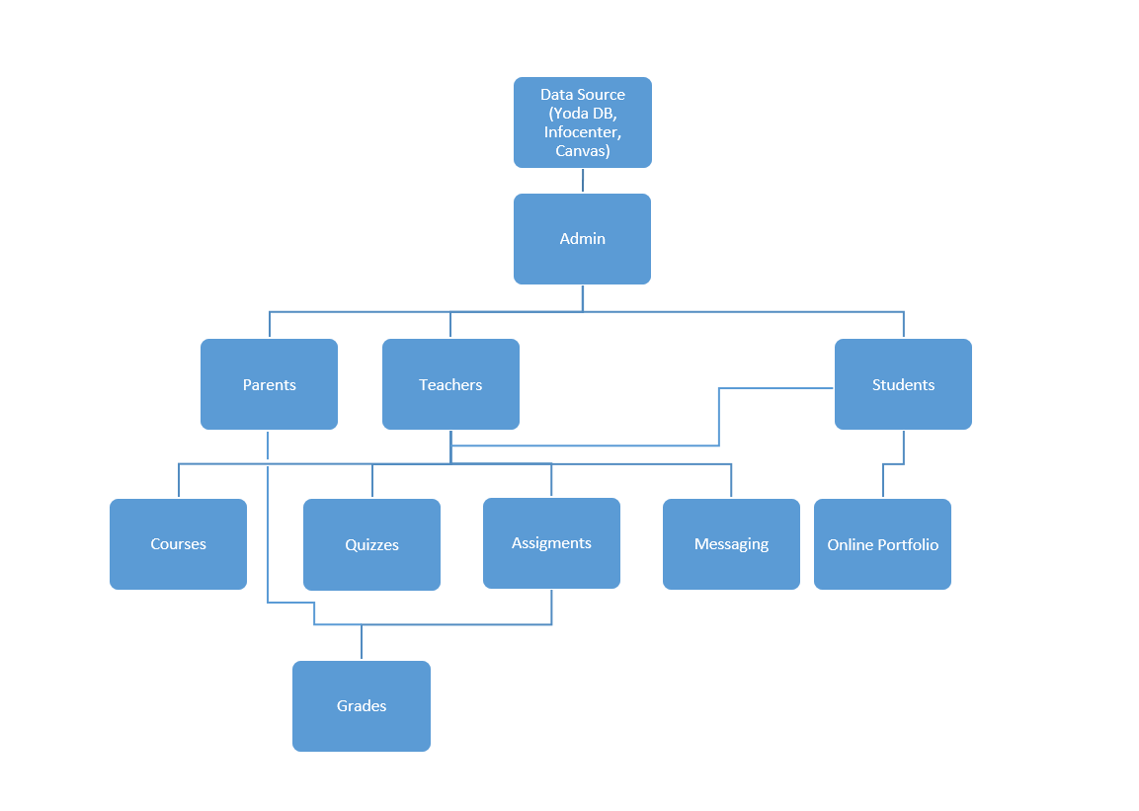Online Portfolio

Project Roadmap